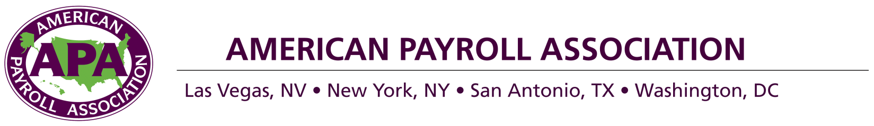
[Date]

[School Address]

Dear [School Administrator],

I am with the [Chapter Name] of the American Payroll Association (APA), a professional organization with more than 21,000 members nationwide. I ask permission to visit your campus on [Date] to teach your students about their paychecks and the payroll withholding system as part of our national Money Matters National Education Day campaign.

My lesson will provide real-world financial literacy training for your students. They will learn to fill out a Form W-4 and will acquire an understanding of how and why payroll taxes are withheld from their paychecks. Since your students will soon be working, this personal finance knowledge will be indispensable as they strive to become financially responsible adults.

Currently 66.6 percent of America’s workers live paycheck to paycheck. With my presentation, I will arm your students with the knowledge and understanding to improve their money management skills, save for the future, and put more money in their pocket with each paycheck.

I’ve enclosed the lesson plan that I will teach from, created by the APA and the Council for Economic Education, for you to review. It is geared toward teens entering the workforce and designed to take approximately one hour. The lesson can be shortened or lengthened depending on the times you have available. There is no charge for this presentation; it is part of APA’s nonprofit, volunteer outreach program to increase payroll and financial literacy.

I will contact you within a week to discuss participation details. For more information, please visit www.nationaleducationday.com. I look forward to partnering with you and [School Name].

Best regards,

[Member Name]
[Chapter Name]
[Address]
[Phone]
[E-mail]

